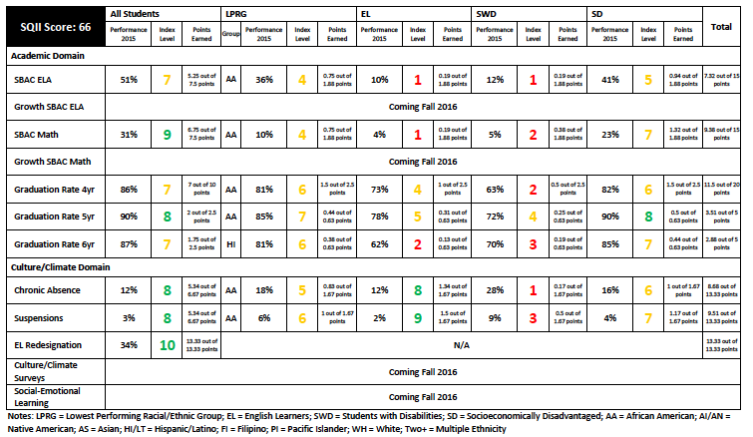
Objective:
- Empower school leaders to communicate effectively the Why, What, and
How of the District’s Federal School Quality Improvement Index (SQII)
- Empower school leaders to understand the relationship between the SQII
and the District’s School Performance Framework (SPF)

Pair Share Prompt:
Consider what comes to mind when you think of a hammer and a flashlight. What is unique about these two tools? Imagine you’ve taken a job as a home inspector and the first day on the job, you ask, “What tool should I use to inspect the home?” and your boss offers you the choice of a hammer or a flashlight; which would you choose?

VS.

Consider an accountability system for school performance.
How would you know an accountability system for school performance had moved from a
hammer of accountability to a flashlight of continuous improvement?

“I would know because…
“I would know if…

Share-out Responses

SQII INTRODUCTION VIDEO

Download Video CORE School Quality Improvement Index (Cut & Paste)
http://qualitycommunityschools.weebly.com/uploads/4/1/6/1/41611/part_1_intro_sqii.mp4

[ME] WHY (video stop point - 1:13)
Where did the School Quality Improvement Index come from?

How is the index an improvement from past accountability systems?

[ME] WHAT (video stop point - 2:12)
What are the key components of the School Quality Improvement Index?
What types of indicators and which ones specifically have been included in the index?

[WE] WHAT (video stop point - 3:32)
What is one guiding principle in the creation of the index that most stands out to you as a worthwhile approach to supporting continuous improvement?

“One guiding principle that stands out to me is…, because…

Share-out Responses

[ME] HOW (video stop point - 5:53)
In what ways is the collaboratively developed Index likely to strengthen it as a tool?

[ME] HOW (video stop point - 7:11)
What is one way the Index is Measurable, Meaningful, and/or Actionable?

[ME] HOW (video stop point - 8:38)
How can I, in simple terms explain the way the Index changes the narrow view of school performance to a more holistic and actionable view of school performance?

[WE] PAUSE and REFLECT (video stop point - 10:39)
What do you find noteworthy and interesting about what you’ve heard so far?
What do you want to learn more about?

What opportunities do you see in the use of this information?

Share-out Responses

SAMPLE SQII FULL REPORTS (checking for understanding)
What are the key components of the SQII Report?
1
2
3
4
5
6
7
8
9

SQII 1-PAGER COMPONENTS (checking for understanding)
What are the key components of the Customized District SQII 1-Pager Report?
1
2
3
4
5
6

